**Actvity: Migrating PostgreSQL to AWS RDS**

* Lets create an ec2 instance with size db.t2.micro and ubuntu 20.04
* Install the PostgreSQL Database on ubuntu 20.04
* To change the bind address

sudo find / -name "postgresql.conf"

* Change the listen_address to ‘*’ from ‘localhost’ in location /etc/postgresql/12/main/postgresql.conf  
  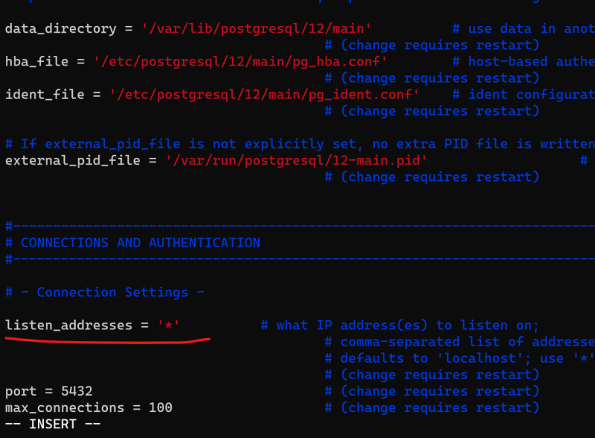  
  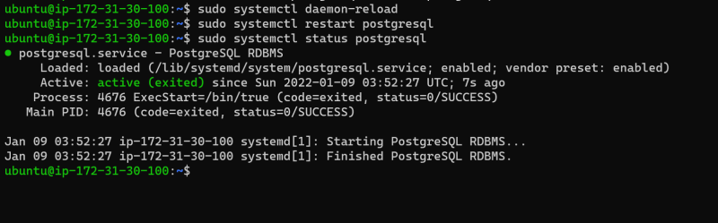
* To connect the postgres from your local system either download pgadmin [Refer Here](https://www.pgadmin.org/download/) or use Azure Data Studio [Refer Here](https://docs.microsoft.com/en-us/sql/azure-data-studio/download-azure-data-studio?view=sql-server-ver15)
* Make changes in pg_hba.conf  
  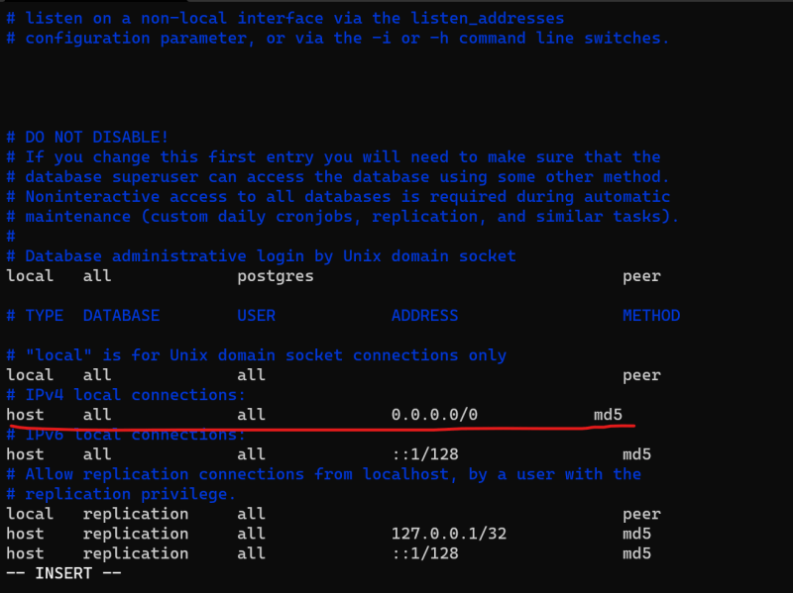
* To make changes and restart service use the below commands  
  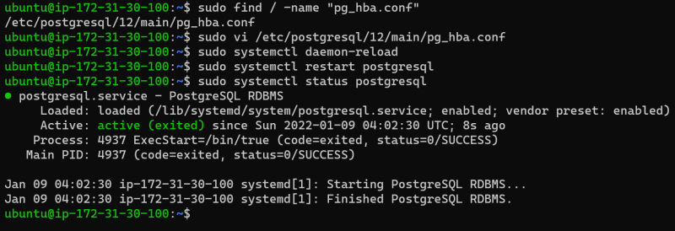
* Change the password for postgres and other users by following below commands  
  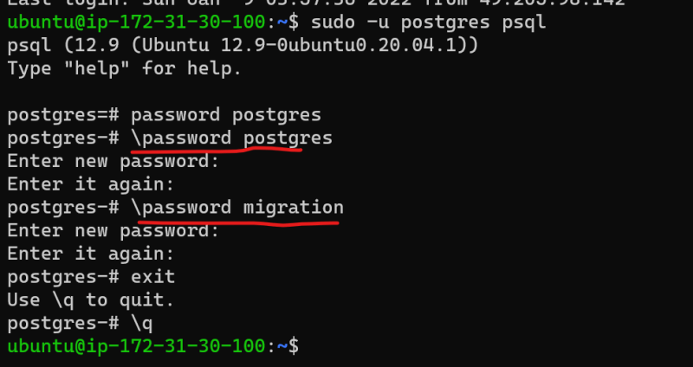
* Now we need a sample db in postgres to migrate.
* To import the sample database execute the following commands

sudo apt install unzip -y

wget https://www.postgresqltutorial.com/wp-content/uploads/2019/05/dvdrental.zip

unzip dvdrental.zip

cp dvdrental.tar /tmp

sudo -i -u posgtgres

psql

CREATE DATABASE dvdrental;

exit

pg_restore -U postgres -d dvdrental /tmp/dvdrental.tar

psql

\c dvdrental

select * from public.actor;